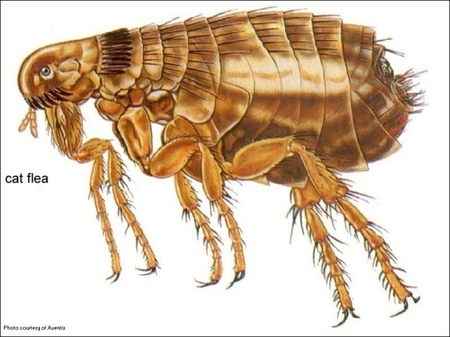

**Home Flea Control**

So, you’ve been treating your pets and/or house for fleas and yet you are still finding them. It must mean your flea product doesn’t work and/or the fleas are resistant to it, right? If you are using some of the older products the answer is possibly. If you are using one of the newer generations of flea control such as Frontline Plus, Revolution, etc. the answer is a resounding NO! There has been no proven resistance with any of the newer generation flea products. The problem is that because they work so well most people do not treat long enough or consistently enough to break the flea life cycle or prevent new infestations. To better understand how to treat fleas let’s review the flea life cycle.

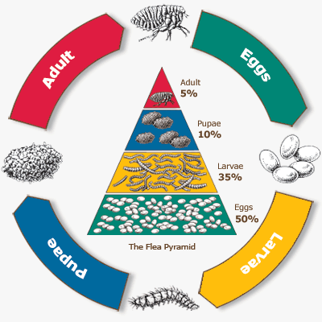

In most households fleas complete a life cycle in 3-4 weeks, depending on temperature and humidity. The life cycle can be completed in as little as 14 days or can occasionally be prolonged for up to 6 months. There are 4 stages in the fleas’ life cycle: egg, larvae, pupae, and adult. Eggs hatch in 1-6 days depending on temperature and humidity. The larval stage usually lasts 5-11 days depending on climate conditions and availability of food. They like to avoid light and move downward in response to gravity, so they are the stage found under beds, sofas, and deep down in the carpet fibers. The pupae is normally fully developed in 7-28 days. They spin a protective silk cocoon and can stay inside it for several days or up to 6 months until stimulated to emerge. There is currently no product that can kill the pupae form. Fleas often emerge from pupal cocoons over a period of 2-4 weeks rather than all at once to maximize the chances of finding a suitable host. This is called the “Pupal window effect”. This effect is the reason new adult fleas continue to emerge up to several months after an insecticide application has killed an adult flea population and also why fleas can still be seen on pets treated with appropriate monthly topicals. If proper products are being used correctly, the fleas seen are newly hatched adults emerging over that 2-4 week period and since pupae can live up to 6 months you can have an almost continual hatch. The newly hatched adults are ravenous and seek a blood meal as soon as possible. They start laying eggs 24-48 hours after the first blood meal. It only takes one female flea to cause a huge problem in your home. A female flea can lay an average of 30 to 50 eggs daily which can add up to more than 2,000 eggs over her lifetime. An adult flea spends its entire life on its host and can live for at least 3-4 months with a constant blood source; if removed from the host it stops reproducing and dies within 3-4 days.

So how can we battle fleas and win? We need to attack as many aspects of their life cycle as possible by treating both the pets and the environment. Adult fleas, eggs and larvae are prone to dehydration: humidity <45% will kill eggs and larvae. This is why they are not found in open lawn areas. Using a dehumidifier indoors and decreasing outdoor vegetation such as fallen leaves, and mulched areas will help make the environment less friendly to fleas. Vacuuming with a beater bar vacuum destroys the outer covering of the adult flea and leaves it open to dehydration. Vacuuming alone can kill up to 59% of eggs, 27% of larvae and a large number of adults. It also helps to stimulate the pupae stage to emerge from their protective cocoons. When treating your house we do not recommend “Bombs” because they only treat vertically; they do not get under objects where larvae are more likely to be found. Most products are only effective against the adult flea, so make sure your product contains an Insect Growth Regulator (IGR). IGRs are made up of compounds that interfere with an insects transition between developmental stages, resulting in death of the insect. Premise sprays with IGRs last up to 3 months so ideally you should treat your home every 3 months initially for at least 1 year. When you treat your home spray all areas in your home, even areas where your pet does not go, like an attached garage, basement, attic etc. After you treat your home it is recommended not to vacuum for 5-7 days so the spray has time to bond with the carpet and reach the bottom fibers.

The goal to dealing with fleas is to realize that what you see in your home is only the tip of the “iceberg”. Do not stop using preventative measures just because adult fleas are no longer seen. This will help prevent the juvenile stages from establishing themselves in your home. This process takes time and patience, but once the environment is controlled you should be able to continue your control by using a good preventative on all your pets year round. Ask our staff members about appropriate products such as premise sprays with IGRs for your home and monthly topicals for your pets.

**Key points for controlling fleas: C:\Users\win5\AppData\Local\Microsoft\Windows\Temporary Internet Files\Content.IE5\6CZXH0W7\MCj04381370000[1].wmf**

1. Vacuum your home very well then clean out your vacuum/ throw away the bag.
2. Treat your home with a premise spray initially and then every 3 months for one year
3. Use a premise spray that contains an Insect Growth Regulator (IGR) on all horizontal surfaces in your home. On all carpeted areas, spray the entire carpet, under beds/dressers, between/under couch cushions etc. For rooms that are not carpeted (hardwood, linoleum, etc…) spray the baseboards or perimeters. Although typically non-staining always test on an inconspicuous spot first.
4. Wash anything your pet lays on such as bedding, rugs, towels, sheets, blankets, etc. in hot water. If there is something you cannot wash spray it with a premise spray. If none of these are options then leave it in direct hot sunlight for about 1 hour to help dry up any eggs or larvae that may be on that object.
5. Treat your pet(s) monthly with a long lasting adulticide, preferably with an IGR such as Frontline Plus. Treat all pets in the household, not just the ones that seem affected by fleas.